- Create a class FRUIT which has data members color, taste and price. Also create a method display() which will print values of FRUIT object. Create three objects of FRUIT class and call their display() methods.
- Create a class FRUIT which has data members color, taste and price. It has a method setDetails() which will set the values of color, taste and price. Also create a method display() which will print values of FRUIT object.
- In previous question, set the values of using color, taste and price using Constructor.
- Add one-argument constructor and two-argument constructor in addition to default constructor in FRUIT class.
- Use the concept of constructor-chaining in the previous question using this().
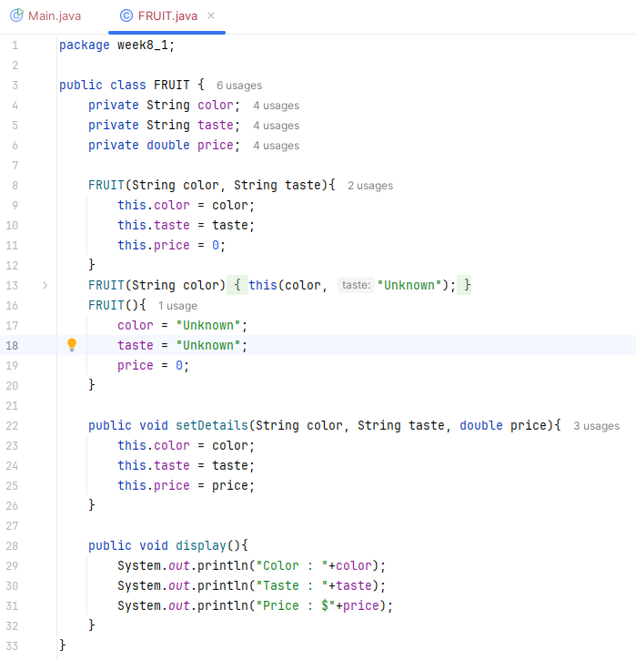
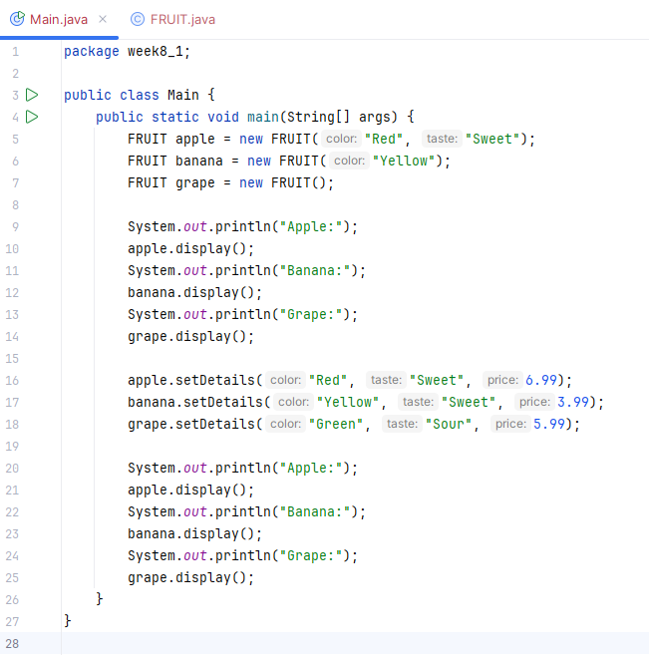
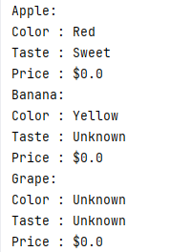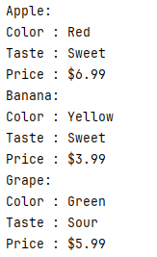
- Create a class CAR with the following details:
Data members: model, color, price.
Member methods:
setDetails() – to set values of all data members using setters.
getDetails() – to get values of all data members using getters.
display() – to print all details of the car.
Requirements:
1. Implement default constructor to initialize default values.
2. Implement a parameterized constructor (with one argument) to set only model.
3. Implement another parameterized constructor (with two arguments) to set model and color.
4. Use constructor chaining to reduce code redundancy.
5. Create three objects of CAR class using:
● Default constructor
● One-argument constructor
● Two-argument constructor
6. Set price for each object using the setDetails() method.
7. Call the display() method for each object.
